**DBMS ASSIGNMENT 2**

**Domain:- Personalized Fashion Styling platform.**

Domain Description:

The Personalized Fashion Styling platform is an online service that connects users with professional stylists to receive personalized fashion advice and outfit recommendations based on their preferences and occasions.

Workflow

The workflow for the "Personalized Fashion Styling" platform involves the interaction between users, stylists, and the system. Here's an overview of the typical workflow:

**Customer Registration:**

Customers register by providing their personal information, including name, email, address, and contact number.

User accounts are created for each customer with a unique username, password, and a reference to the corresponding customer profile.

**Stylist Registration:**

Stylists register by providing their details, such as name, username, password, experience level, and specialization.

**Style Preferences and Occasions:**

Users choose their preferred style preferences from options like Elegant, Professional, Casual, etc.

Users also select occasions for which they need styling assistance, such as Wedding, Job Interview, Night Out, etc.

**Outfit Selection:**

Users browse and choose outfits from the available options, each associated with a specific style preference.

**Stylist Outfit Selection:**

Stylists select outfits for each user, considering the user's style preferences, occasions, and their own expertise.

The chosen stylist-outfit combinations are recorded in the Stylist_Outfit_Choosen table.

**Order Placement:**

Users place orders by selecting a stylist-outfit combination.

Orders are recorded in the Order table along with the associated user, chosen stylist-outfit combination, and the order date.

**Payment:**

Users make payments for their orders using different payment methods (Credit Card, PayPal, Debit Card).

Payment details are recorded in the Payment table, associated with the corresponding order.

**Completion of Styling Service:**

Stylists provide personalized fashion styling based on the chosen outfit and user preferences.

**Entity Relationship Diagram**

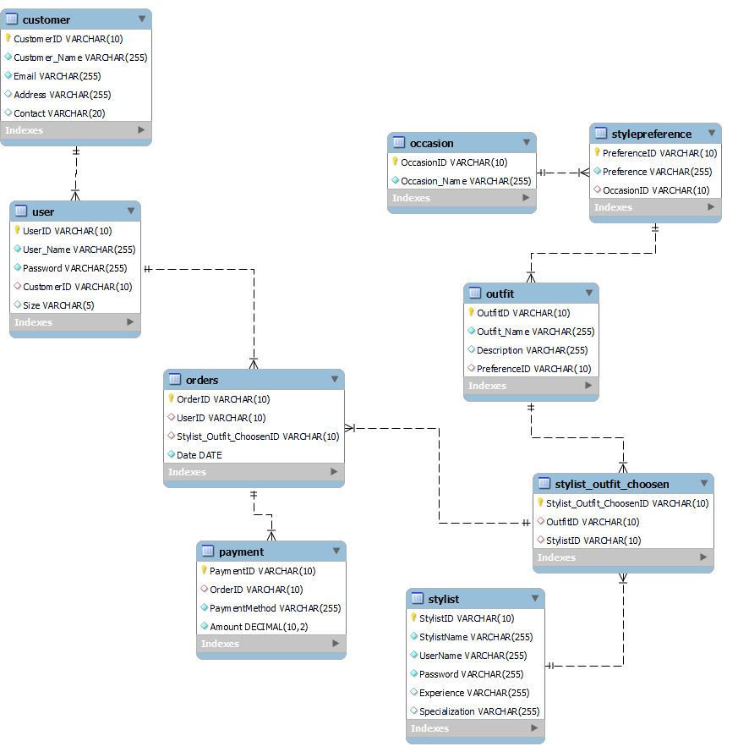

**Tables**

**Customer table**

|  |  |  |
| --- | --- | --- |
| Attributes | Data Types | Constraints |
| CustomerID | VARCHAR | Primary Key |
| Customer_Name | VARCHAR | Not Null |
| Email | VARCHAR | Unique, Not Null |
| Address | VARCHAR |  |
| Contact | VARCHAR |  |

**User table**

|  |  |  |
| --- | --- | --- |
| Attributes | Data Types | Constraints |
| UserID | VARCHAR | Primary Key |
| UserID | VARCHAR | Not Null |
| Password | VARCHAR | Not Null |
| CustomerID | VARCHAR | Foreign Key (Customer) |
| Size | VARCHAR |  |

**Stylist Table**

|  |  |  |
| --- | --- | --- |
| Attributes | Data Types | Constraints |
| StylistID | VARCHAR | Primary Key |
| StylistName | VARCHAR | Not Null |
| UserName | VARCHAR | Unique, Not Null |
| Password | VARCHAR | Not Null |
| Experience | VARCHAR |  |
| Specialization | VARCHAR |  |

**Occasion Table**

|  |  |  |
| --- | --- | --- |
| Attributes | Data Types | Constraints |
| OccasionID | VARCHAR | Primary Key |
| Occasion_Name | VARCHAR | Not Null |

**StylePreference**

|  |  |  |
| --- | --- | --- |
| Attributes | Data Types | Constraints |
| PreferenceID | VARCHAR | Primary Key |
| Preference | VARCHAR | Not Null |
| OccasionID | VARCHAR |  |

### **Outfit Table**:

|  |  |  |
| --- | --- | --- |
| Attribute | Data Type | Constraints |
| OutfitID | VARCHAR | Primary Key |
| Outfit_Name | VARCHAR | Not Null |
| Description | VARCHAR |  |
| PreferenceID | VARCHAR | Foreign Key (Preference) |

### **Stylist_Outfit_Choosen Table:**

|  |  |  |
| --- | --- | --- |
| Attribute | Data Type | Constraints |
| Stylist_Outfit_ChoosenID | VARCHAR | Primary Key |
| OutfitID | VARCHAR | Foreign Key (Outfit) |
| StylistID | VARCHAR | Foreign Key (Stylist) |

### **Order Table:**

|  |  |  |
| --- | --- | --- |
| Attribute | Data Type | Constraints |
| OrderID | VARCHAR | Primary Key |
| UserID | VARCHAR | Foreign Key (User) |
| Stylist_Outfit_ChoosenID | VARCHAR | Foreign Key (Stylist_Outfit_Choosen) |
| Date | DATE | Not Null |

### **Payment Table:**

|  |  |  |
| --- | --- | --- |
| Attribute | Data Type | Constraints |
| PaymentID | VARCHAR | Primary Key |
| OrderID | VARCHAR | Foreign Key (Order) |
| PaymentMethod | VARCHAR | Not Null |
| Amount | DECIMAL | Not Null |